MODULE – 3(Core PHP)

Q-1 .Write a PHP program to enter marks of five subjects Physics, Chemistry, Biology, Mathematics and Computer, calculate percentage and grade by if else write a PHP program for find „Thursday‟ in week using switch Function.

Ans :

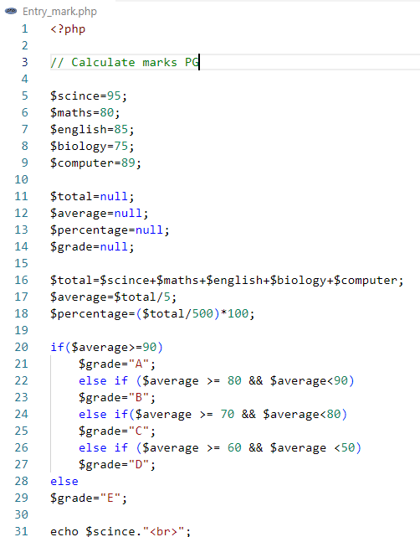

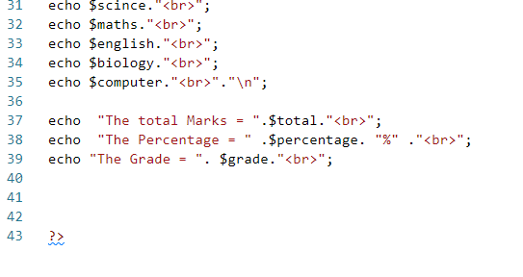

O/P:

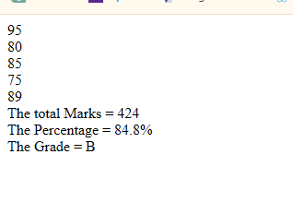

2. write a PHP program for find „Thursday‟ in week using switch Function.

Ans :

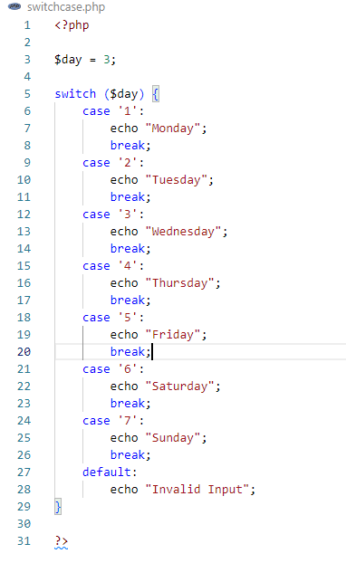

O/P:

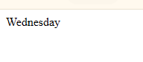

3. Write a PHP program to check Leap years between 1901 to 2016 Using nested if.

Ans :

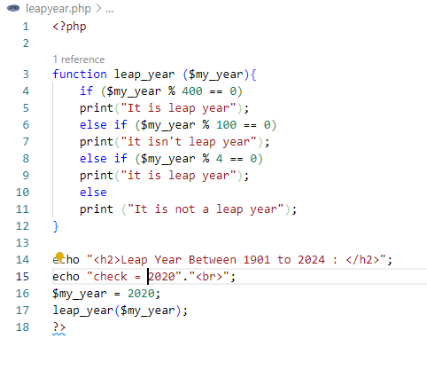

O/P:

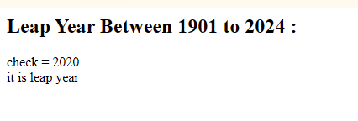

4. Write a PHP program to find the largest of three numbers using ternary Operator.

Ans :

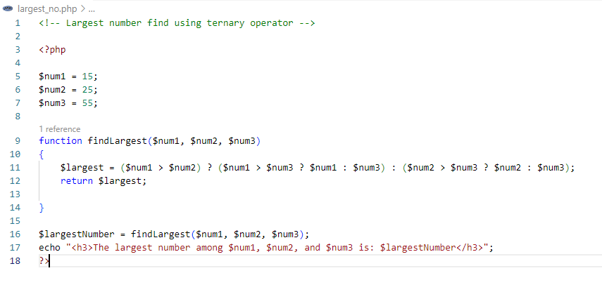

O/P:

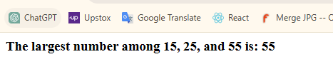

5. Write a program in PHP to print Fibonacci series. 0, 1, 1, 2, 3, 5, 8, 13, 21, o 34.

Ans :

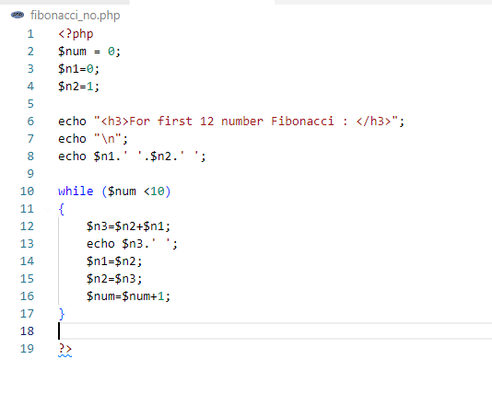

O/P:

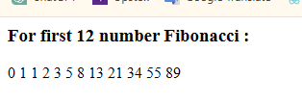

6. Write a program to find whether a number is Armstrong or not Write a program to print the below format:

5 9

2610

3711

4812

Ans :

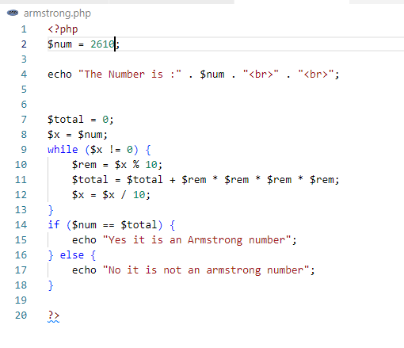

O/P:

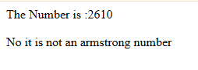

7. Write a program for this Pattern:

\*\*\*\*\*

\*

\*

\*

\*\*\*\*\*

Ans :

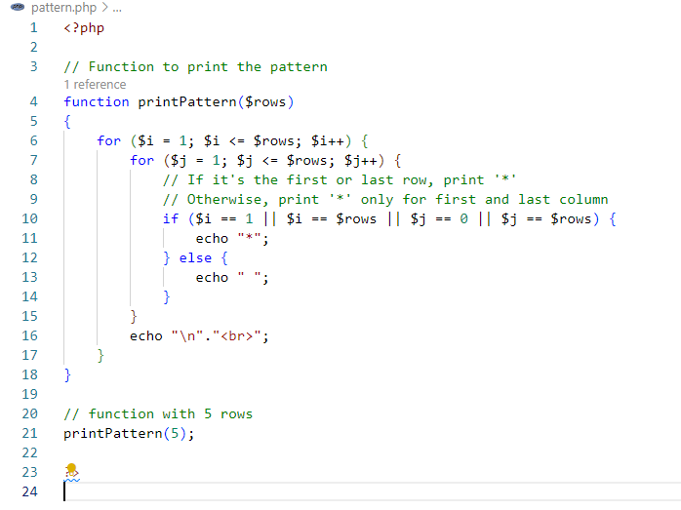

O/P:

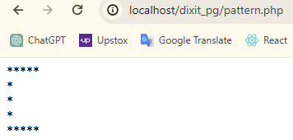

8. What will be the values of $a and $b after the code below is executed? Explain your answer.

$a = '1';

$b = &$a;

$b = "2$b";

Ans :

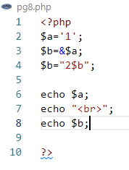

O/P:

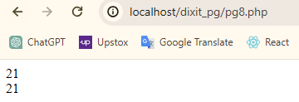

Here's what's happening step by step:

1.$a is assigned the value '1'.

2.$b is assigned a reference to $a, so both $a and $b point to the same memory location.

3.$b is modified by concatenating '2' with its current value, which results in '21'.

Now, $a and $b both hold the value '21'.

9. How can you tell if a number is even or odd without using any Condition or loop?

Ans :

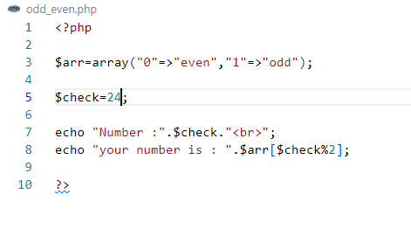

O/P:

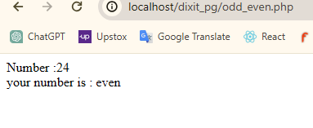

10. How can you declare the array (all type) in PHP? Explain with example Covert a JSON string to array.

Ans :

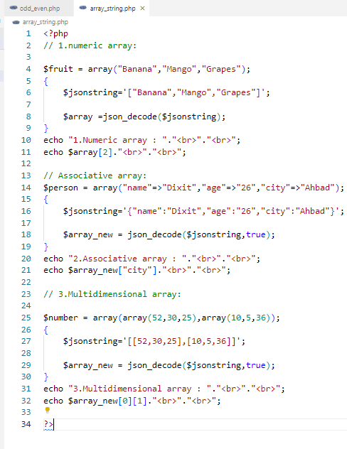

O/P:

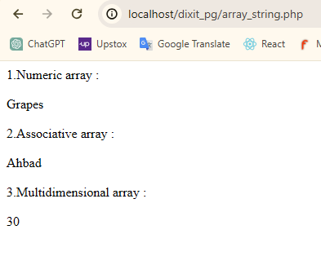

11. Write program to remove duplicate values from array.

Ans :

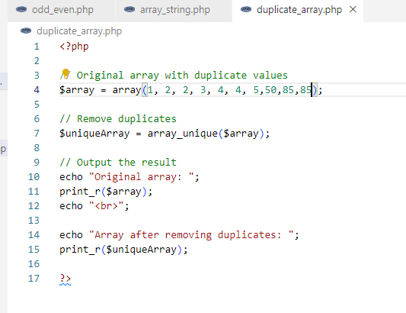

O/P:

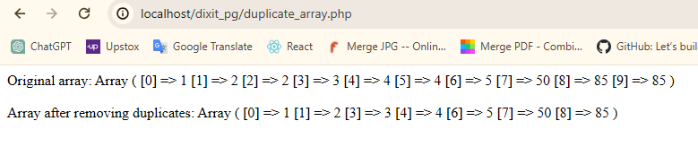

12. Get random values from array.

Ans :

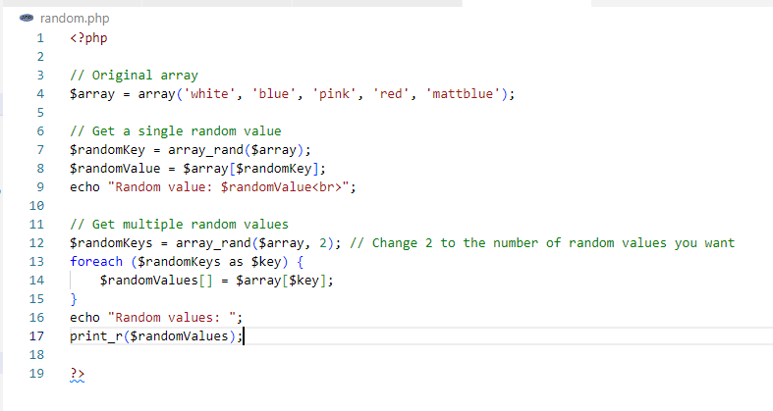

O/P:

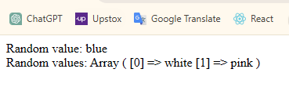

13. Write a PHP script which decodes the following JSON string.

Ans : 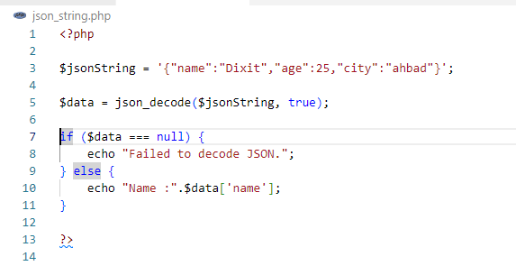

O/P:

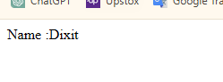

14. Use a for loop to total the contents of an integer array called numbers which has five elements. Store the result in an integer called total Output

Ans :

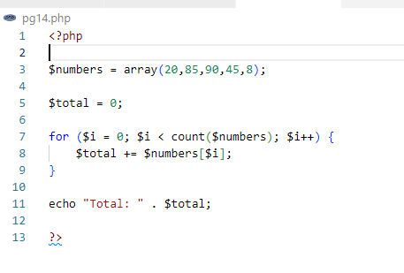

O/P:

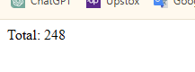

15. Declare a Multi Dimensioned array of floats called balances having Three rows and five columns.

Ans :

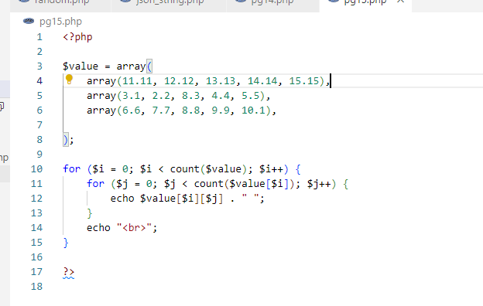

O/P:

